WEEK – 2

PL SQL

EXERCISE 1:Control Structures (MANDATORY)

SCENARIO 1: The bank wants to apply a discount to loan interest rates for customers above 60 years old.

ALTER TABLE Customers ADD IsVIP VARCHAR2(5);

INSERT INTO Customers (CustomerID, Name, DOB, Balance, LastModified)

VALUES (3, 'Elder John', TO_DATE('1950-01-01', 'YYYY-MM-DD'), 8000, SYSDATE);

INSERT INTO Loans (LoanID, CustomerID, LoanAmount, InterestRate, StartDate, EndDate)

VALUES (2, 3, 10000, 6, SYSDATE, ADD_MONTHS(SYSDATE, 60));

SET SERVEROUTPUT ON;

DECLARE

v_age NUMBER;

BEGIN

FOR cust IN (SELECT CustomerID, DOB FROM Customers) LOOP

v_age := FLOOR(MONTHS_BETWEEN(SYSDATE, cust.DOB) / 12);

IF v_age > 60 THEN

UPDATE Loans

SET InterestRate = InterestRate - 1

WHERE CustomerID = cust.CustomerID;

DBMS_OUTPUT.PUT_LINE('Applied 1% discount for Customer ID: ' || cust.CustomerID);

END IF;

END LOOP;

COMMIT;

END;

/

**Output:**

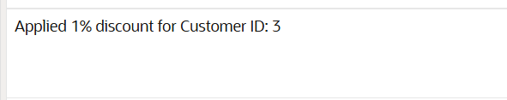

SCENARIO 2: A customer can be promoted to VIP status based on their balance.

INSERT INTO Customers (CustomerID, Name, DOB, Balance, LastModified)

VALUES (4, 'VIP Lisa', TO_DATE('1995-02-10', 'YYYY-MM-DD'), 15000, SYSDATE);

BEGIN

FOR cust IN (SELECT CustomerID, Balance FROM Customers) LOOP

IF cust.Balance > 10000 THEN

UPDATE Customers

SET IsVIP = 'TRUE'

WHERE CustomerID = cust.CustomerID;

DBMS_OUTPUT.PUT_LINE('Customer ' || cust.CustomerID || ' marked as VIP');

ELSE

UPDATE Customers

SET IsVIP = 'FALSE'

WHERE CustomerID = cust.CustomerID;

END IF;

END LOOP;

COMMIT;

END;

/

**Output:**

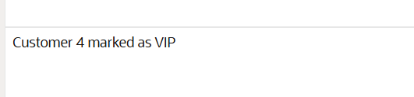

SCENARIO 3: The bank wants to send reminders to customers whose loans are due within the next 30 days.

INSERT INTO Loans (LoanID, CustomerID, LoanAmount, InterestRate, StartDate, EndDate)

VALUES (3, 4, 3000, 5, SYSDATE - 330, SYSDATE + 10); -- due in 10 days

BEGIN

FOR l IN (

SELECT l.LoanID, l.CustomerID, c.Name, l.EndDate

FROM Loans l

JOIN Customers c ON l.CustomerID = c.CustomerID

WHERE l.EndDate BETWEEN SYSDATE AND SYSDATE + 30

) LOOP

DBMS_OUTPUT.PUT_LINE(

'Reminder: Loan ID ' || l.LoanID || ' for customer ' || l.Name ||

' is due on ' || TO_CHAR(l.EndDate, 'YYYY-MM-DD')

);

END LOOP;

END;

/

**Output:**

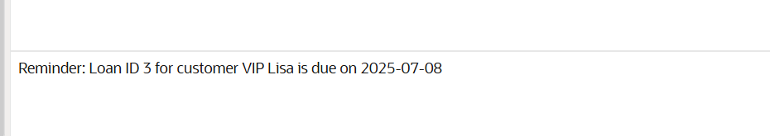

EXERCISE 2: Error Handling

SCENARIO 1: Handle exceptions during fund transfers between accounts.

UPDATE Accounts SET Balance = 1000 WHERE AccountID = 1;

UPDATE Accounts SET Balance = 1500 WHERE AccountID = 2;

COMMIT;

CREATE OR REPLACE PROCEDURE SafeTransferFunds (

p_from_account IN NUMBER,

p_to_account IN NUMBER,

p_amount IN NUMBER

) AS

v_balance NUMBER;

BEGIN

SELECT Balance INTO v_balance FROM Accounts WHERE AccountID = p_from_account;

IF v_balance < p_amount THEN

RAISE_APPLICATION_ERROR(-20001, 'Insufficient funds in source account.');

END IF;

UPDATE Accounts

SET Balance = Balance - p_amount

WHERE AccountID = p_from_account;

UPDATE Accounts

SET Balance = Balance + p_amount

WHERE AccountID = p_to_account;

COMMIT;

DBMS_OUTPUT.PUT_LINE('Transfer successful.');

EXCEPTION

WHEN OTHERS THEN

ROLLBACK;

DBMS_OUTPUT.PUT_LINE('Error: ' || SQLERRM);

END;

/

BEGIN

SafeTransferFunds(1, 2, 500);

END;

/

**Output:**

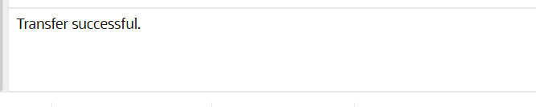

SCENARIO 2: Manage errors when updating employee salaries.

CREATE OR REPLACE PROCEDURE UpdateSalary (

p_emp_id IN NUMBER,

p_percent IN NUMBER

) AS

BEGIN

UPDATE Employees

SET Salary = Salary + (Salary * p_percent / 100)

WHERE EmployeeID = p_emp_id;

IF SQL%ROWCOUNT = 0 THEN

RAISE_APPLICATION_ERROR(-20002, 'Employee ID not found.');

END IF;

COMMIT;

DBMS_OUTPUT.PUT_LINE('Salary updated successfully.');

EXCEPTION

WHEN OTHERS THEN

ROLLBACK;

DBMS_OUTPUT.PUT_LINE('Error: ' || SQLERRM);

END;

/

BEGIN

UpdateSalary(1, 10);

END;

/

**Output:**



SCENARIO 3: Ensure data integrity when adding a new customer.

CREATE OR REPLACE PROCEDURE AddNewCustomer (

p_id IN NUMBER,

p_name IN VARCHAR2,

p_dob IN DATE,

p_balance IN NUMBER

) AS

BEGIN

INSERT INTO Customers (CustomerID, Name, DOB, Balance, LastModified)

VALUES (p_id, p_name, p_dob, p_balance, SYSDATE);

COMMIT;

DBMS_OUTPUT.PUT_LINE('Customer added successfully.');

EXCEPTION

WHEN DUP_VAL_ON_INDEX THEN

ROLLBACK;

DBMS_OUTPUT.PUT_LINE('Error: Customer ID already exists.');

WHEN OTHERS THEN

ROLLBACK;

DBMS_OUTPUT.PUT_LINE('Unexpected Error: ' || SQLERRM);

END;

/

BEGIN

AddNewCustomer(10, 'New Customer', TO_DATE('1999-01-01', 'YYYY-MM-DD'), 1200);

END;

/

**Output:**

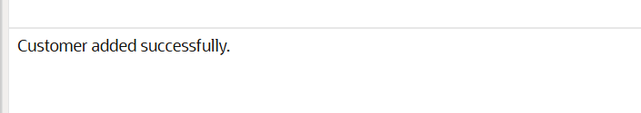

EXERCISE 3: Stored Procedures (MANDATORY)

SCENARIO 1: The bank needs to process monthly interest for all savings accounts.

CREATE OR REPLACE PROCEDURE ProcessMonthlyInterest IS

BEGIN

FOR acc IN (

SELECT AccountID, Balance

FROM Accounts

WHERE AccountType = 'Savings'

) LOOP

UPDATE Accounts

SET Balance = Balance + (acc.Balance * 0.01),

LastModified = SYSDATE

WHERE AccountID = acc.AccountID;

DBMS_OUTPUT.PUT_LINE('Interest added to Account ID: ' || acc.AccountID);

END LOOP;

COMMIT;

END;

/

UPDATE Accounts SET Balance = 1000 WHERE AccountID = 1; -- Savings

COMMIT;

BEGIN

ProcessMonthlyInterest;

END;

/

**Output:**



SCENARIO 2: The bank wants to implement a bonus scheme for employees based on their performance.

CREATE OR REPLACE PROCEDURE UpdateEmployeeBonus (

p_department IN VARCHAR2,

p_bonus_percent IN NUMBER

) IS

BEGIN

FOR emp IN (

SELECT EmployeeID, Salary

FROM Employees

WHERE Department = p_department

) LOOP

UPDATE Employees

SET Salary = Salary + (emp.Salary * p_bonus_percent / 100)

WHERE EmployeeID = emp.EmployeeID;

DBMS_OUTPUT.PUT_LINE('Bonus applied to Employee ID: ' || emp.EmployeeID);

END LOOP;

COMMIT;

END;

/

**Output:**

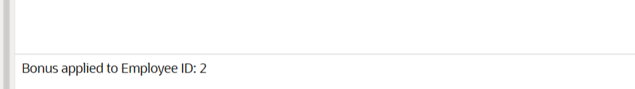

SCENARIO 3: Customers should be able to transfer funds between their accounts.

CREATE OR REPLACE PROCEDURE TransferFunds (

p_from_acc IN NUMBER,

p_to_acc IN NUMBER,

p_amount IN NUMBER

) IS

v_balance NUMBER;

BEGIN

SELECT Balance INTO v_balance FROM Accounts WHERE AccountID = p_from_acc;

IF v_balance < p_amount THEN

RAISE_APPLICATION_ERROR(-20003, 'Insufficient funds.');

END IF;

UPDATE Accounts

SET Balance = Balance - p_amount,

LastModified = SYSDATE

WHERE AccountID = p_from_acc;

UPDATE Accounts

SET Balance = Balance + p_amount,

LastModified = SYSDATE

WHERE AccountID = p_to_acc;

COMMIT;

DBMS_OUTPUT.PUT_LINE('Transfer complete.');

EXCEPTION

WHEN OTHERS THEN

ROLLBACK;

DBMS_OUTPUT.PUT_LINE('Error: ' || SQLERRM);

END;

/

UPDATE Accounts SET Balance = 1000 WHERE AccountID = 1; -- Source

UPDATE Accounts SET Balance = 500 WHERE AccountID = 2; -- Destination

COMMIT;

**Output:**

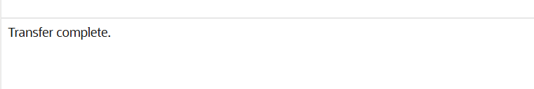

EXERCISE 4: Functions

SCENARIO 1: Calculate the age of customers for eligibility checks.

CREATE OR REPLACE FUNCTION CalculateAge (

p_dob IN DATE

) RETURN NUMBER IS

v_age NUMBER;

BEGIN

v_age := FLOOR(MONTHS_BETWEEN(SYSDATE, p_dob) / 12);

RETURN v_age;

END;

/

SET SERVEROUTPUT ON;

DECLARE

v_age NUMBER;

BEGIN

v_age := CalculateAge(TO_DATE('1960-06-15', 'YYYY-MM-DD'));

DBMS_OUTPUT.PUT_LINE('Age: ' || v_age);

END;

/

**Output:**

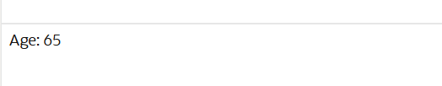

SCENARIO 2: The bank needs to compute the monthly installment for a loan.

CREATE OR REPLACE FUNCTION CalculateMonthlyInstallment (

p_loan_amount IN NUMBER,

p_annual_rate IN NUMBER,

p_years IN NUMBER

) RETURN NUMBER IS

v_monthly_rate NUMBER;

v_months NUMBER;

v_emi NUMBER;

BEGIN

v_monthly_rate := p_annual_rate / 12 / 100;

v_months := p_years * 12;

IF v_monthly_rate = 0 THEN

v_emi := p_loan_amount / v_months;

ELSE

v_emi := p_loan_amount * v_monthly_rate * POWER(1 + v_monthly_rate, v_months) /

(POWER(1 + v_monthly_rate, v_months) - 1);

END IF;

RETURN ROUND(v_emi, 2);

END;

/

DECLARE

v_emi NUMBER;

BEGIN

v_emi := CalculateMonthlyInstallment(10000, 12, 2); -- 2 years, 12% annual

DBMS_OUTPUT.PUT_LINE('Monthly Installment: $' || v_emi);

END;

/

**Output:**



SCENARIO 3: Check if a customer has sufficient balance before making a transaction.

CREATE OR REPLACE FUNCTION HasSufficientBalance (

p_account_id IN NUMBER,

p_amount IN NUMBER

) RETURN BOOLEAN IS

v_balance NUMBER;

BEGIN

SELECT Balance INTO v_balance FROM Accounts WHERE AccountID = p_account_id;

RETURN v_balance >= p_amount;

EXCEPTION

WHEN NO_DATA_FOUND THEN

RETURN FALSE;

END;

/

DECLARE

v_ok BOOLEAN;

BEGIN

v_ok := HasSufficientBalance(1, 200); -- Assuming Account 1 exists

IF v_ok THEN

DBMS_OUTPUT.PUT_LINE('Sufficient balance.');

ELSE

DBMS_OUTPUT.PUT_LINE('Insufficient balance.');

END IF;

END;

/

**Output:**

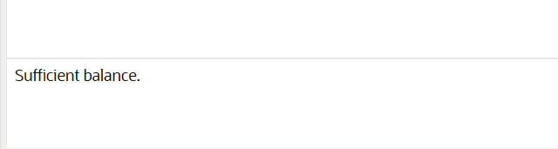

EXERCISE 5: Triggers

SCENARIO 1: Automatically update the last modified date when a customer's record is updated.

CREATE OR REPLACE TRIGGER UpdateCustomerLastModified

BEFORE UPDATE ON Customers

FOR EACH ROW

BEGIN

:NEW.LastModified := SYSDATE;

END;

/

-- Simulate update to customer record

UPDATE Customers

SET Name = 'John D. Doe'

WHERE CustomerID = 1;

**Output:**

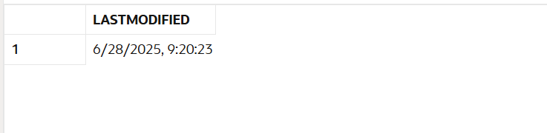

SCENARIO 2: Maintain an audit log for all transactions.

CREATE TABLE AuditLog (

LogID NUMBER GENERATED ALWAYS AS IDENTITY PRIMARY KEY,

TransactionID NUMBER,

AccountID NUMBER,

Amount NUMBER,

TransactionType VARCHAR2(10),

LogDate DATE

);

CREATE OR REPLACE TRIGGER LogTransaction

AFTER INSERT ON Transactions

FOR EACH ROW

BEGIN

INSERT INTO AuditLog (TransactionID, AccountID, Amount, TransactionType, LogDate)

VALUES (:NEW.TransactionID, :NEW.AccountID, :NEW.Amount, :NEW.TransactionType, SYSDATE);

END;

/

INSERT INTO Transactions (TransactionID, AccountID, TransactionDate, Amount, TransactionType)

VALUES (3, 1, SYSDATE, 150, 'Deposit');

SELECT * FROM AuditLog WHERE TransactionID = 3;

**Output:**

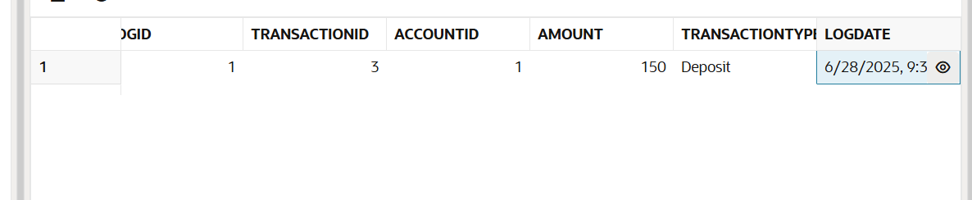

SCENARIO 3: Enforce business rules on deposits and withdrawals.

CREATE OR REPLACE TRIGGER CheckTransactionRules

BEFORE INSERT ON Transactions

FOR EACH ROW

DECLARE

v_balance NUMBER;

BEGIN

SELECT Balance INTO v_balance FROM Accounts WHERE AccountID = :NEW.AccountID;

IF :NEW.TransactionType = 'Withdrawal' AND :NEW.Amount > v_balance THEN

RAISE_APPLICATION_ERROR(-20001, 'Withdrawal exceeds available balance.');

ELSIF :NEW.TransactionType = 'Deposit' AND :NEW.Amount <= 0 THEN

RAISE_APPLICATION_ERROR(-20002, 'Deposit amount must be positive.');

END IF;

END;

/

INSERT INTO Transactions (TransactionID, AccountID, TransactionDate, Amount, TransactionType)

VALUES (4, 1, SYSDATE, 100, 'Deposit');

BEGIN

INSERT INTO Transactions (TransactionID, AccountID, TransactionDate, Amount, TransactionType)

VALUES (5, 1, SYSDATE, -50, 'Deposit');

END;

/

BEGIN

INSERT INTO Transactions (TransactionID, AccountID, TransactionDate, Amount, TransactionType)

VALUES (6, 1, SYSDATE, 9999, 'Withdrawal');

END;

/

**Output:**

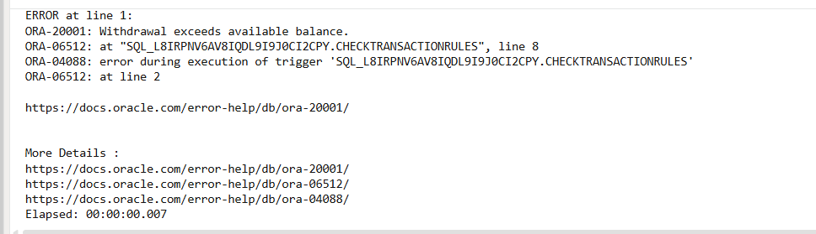

EXERCISE 6: Cursors

SCENARIO 1: Generate monthly statements for all customers.

SET SERVEROUTPUT ON;

DECLARE

CURSOR txn_cursor IS

SELECT c.Name, a.AccountID, t.Amount, t.TransactionType, t.TransactionDate

FROM Customers c

JOIN Accounts a ON c.CustomerID = a.CustomerID

JOIN Transactions t ON a.AccountID = t.AccountID

WHERE EXTRACT(MONTH FROM t.TransactionDate) = EXTRACT(MONTH FROM SYSDATE)

AND EXTRACT(YEAR FROM t.TransactionDate) = EXTRACT(YEAR FROM SYSDATE)

ORDER BY c.CustomerID, t.TransactionDate;

v_record txn_cursor%ROWTYPE;

BEGIN

OPEN txn_cursor;

LOOP

FETCH txn_cursor INTO v_record;

EXIT WHEN txn_cursor%NOTFOUND;

DBMS_OUTPUT.PUT_LINE(

'Customer: ' || v_record.Name ||

' | Account: ' || v_record.AccountID ||

' | Type: ' || v_record.TransactionType ||

' | Amount: ' || v_record.Amount ||

' | Date: ' || TO_CHAR(v_record.TransactionDate, 'YYYY-MM-DD')

);

END LOOP;

CLOSE txn_cursor;

END;

/

**Output:**

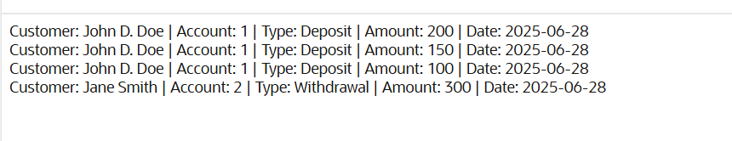

SCENARIO 2: Apply annual fee to all accounts.

SET SERVEROUTPUT ON;

DECLARE

CURSOR acc_cursor IS

SELECT AccountID, Balance

FROM Accounts;

v_acc acc_cursor%ROWTYPE;

v_fee CONSTANT NUMBER := 50; -- Example flat fee

BEGIN

OPEN acc_cursor;

LOOP

FETCH acc_cursor INTO v_acc;

EXIT WHEN acc_cursor%NOTFOUND;

IF v_acc.Balance >= v_fee THEN

UPDATE Accounts

SET Balance = Balance - v_fee,

LastModified = SYSDATE

WHERE AccountID = v_acc.AccountID;

DBMS_OUTPUT.PUT_LINE(

'Annual fee applied to Account ID: ' || v_acc.AccountID

);

ELSE

DBMS_OUTPUT.PUT_LINE(

'Skipped Account ID: ' || v_acc.AccountID || ' due to low balance.'

);

END IF;

END LOOP;

CLOSE acc_cursor;

COMMIT;

END;

/

**Output:**

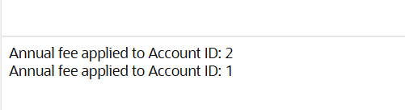

SCENARIO 3: Update the interest rate for all loans based on a new policy.

SET SERVEROUTPUT ON;

DECLARE

CURSOR loan_cursor IS

SELECT LoanID, InterestRate, LoanAmount

FROM Loans;

v_loan loan_cursor%ROWTYPE;

BEGIN

OPEN loan_cursor;

LOOP

FETCH loan_cursor INTO v_loan;

EXIT WHEN loan_cursor%NOTFOUND;

IF v_loan.LoanAmount > 10000 THEN

UPDATE Loans

SET InterestRate = InterestRate - 0.5

WHERE LoanID = v_loan.LoanID;

DBMS_OUTPUT.PUT_LINE(

'Interest reduced for Loan ID: ' || v_loan.LoanID

);

ELSE

DBMS_OUTPUT.PUT_LINE(

'No change for Loan ID: ' || v_loan.LoanID

);

END IF;

END LOOP;

CLOSE loan_cursor;

COMMIT;

END;

/

**Output:**

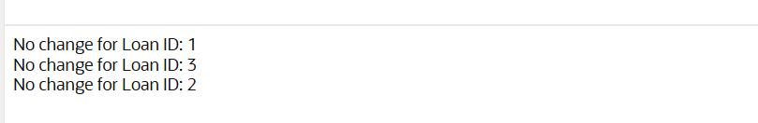

EXERCISE 7: Packages

SCENARIO 1: Group all customer-related procedures and functions into a package.

CREATE OR REPLACE PACKAGE CustomerManagement AS

PROCEDURE AddCustomer(p_id NUMBER, p_name VARCHAR2, p_dob DATE, p_balance NUMBER);

PROCEDURE UpdateCustomer(p_id NUMBER, p_name VARCHAR2, p_balance NUMBER);

FUNCTION GetCustomerBalance(p_id NUMBER) RETURN NUMBER;

END CustomerManagement;

/

CREATE OR REPLACE PACKAGE BODY CustomerManagement AS

PROCEDURE AddCustomer(p_id NUMBER, p_name VARCHAR2, p_dob DATE, p_balance NUMBER) IS

BEGIN

INSERT INTO Customers (CustomerID, Name, DOB, Balance, LastModified)

VALUES (p_id, p_name, p_dob, p_balance, SYSDATE);

DBMS_OUTPUT.PUT_LINE('Customer added: ' || p_name);

COMMIT;

EXCEPTION

WHEN DUP_VAL_ON_INDEX THEN

DBMS_OUTPUT.PUT_LINE('Error: Customer ID already exists.');

ROLLBACK;

END;

PROCEDURE UpdateCustomer(p_id NUMBER, p_name VARCHAR2, p_balance NUMBER) IS

BEGIN

UPDATE Customers

SET Name = p_name, Balance = p_balance, LastModified = SYSDATE

WHERE CustomerID = p_id;

IF SQL%ROWCOUNT = 0 THEN

DBMS_OUTPUT.PUT_LINE('Customer not found.');

ELSE

DBMS_OUTPUT.PUT_LINE('Customer updated: ' || p_name);

END IF;

COMMIT;

END;

FUNCTION GetCustomerBalance(p_id NUMBER) RETURN NUMBER IS

v_balance NUMBER;

BEGIN

SELECT Balance INTO v_balance FROM Customers WHERE CustomerID = p_id;

RETURN v_balance;

EXCEPTION

WHEN NO_DATA_FOUND THEN

RETURN -1;

END;

END CustomerManagement;

/

BEGIN

CustomerManagement.AddCustomer(20, 'Charlie King', TO_DATE('1990-02-10', 'YYYY-MM-DD'), 2500);

END;

/

BEGIN

CustomerManagement.UpdateCustomer(20, 'Charles King', 3000);

END;

/

DECLARE

v_bal NUMBER;

BEGIN

v_bal := CustomerManagement.GetCustomerBalance(20);

DBMS_OUTPUT.PUT_LINE('Customer 20 Balance: ' || v_bal);

END;

/

**Output:**

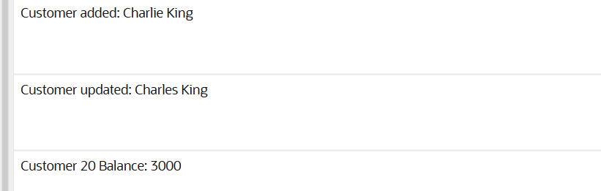

SCENARIO 2: Create a package to manage employee data.

CREATE OR REPLACE PACKAGE EmployeeManagement AS

PROCEDURE HireEmployee(p_id NUMBER, p_name VARCHAR2, p_position VARCHAR2,

p_salary NUMBER, p_department VARCHAR2, p_hire_date DATE);

PROCEDURE UpdateEmployee(p_id NUMBER, p_salary NUMBER);

FUNCTION GetAnnualSalary(p_id NUMBER) RETURN NUMBER;

END EmployeeManagement;

/

CREATE OR REPLACE PACKAGE BODY EmployeeManagement AS

PROCEDURE HireEmployee(p_id NUMBER, p_name VARCHAR2, p_position VARCHAR2,

p_salary NUMBER, p_department VARCHAR2, p_hire_date DATE) IS

BEGIN

INSERT INTO Employees (EmployeeID, Name, Position, Salary, Department, HireDate)

VALUES (p_id, p_name, p_position, p_salary, p_department, p_hire_date);

DBMS_OUTPUT.PUT_LINE('Employee hired: ' || p_name);

COMMIT;

EXCEPTION

WHEN DUP_VAL_ON_INDEX THEN

DBMS_OUTPUT.PUT_LINE('Error: Employee ID already exists.');

ROLLBACK;

END;

PROCEDURE UpdateEmployee(p_id NUMBER, p_salary NUMBER) IS

BEGIN

UPDATE Employees SET Salary = p_salary WHERE EmployeeID = p_id;

IF SQL%ROWCOUNT = 0 THEN

DBMS_OUTPUT.PUT_LINE('Employee not found.');

ELSE

DBMS_OUTPUT.PUT_LINE('Employee salary updated.');

END IF;

COMMIT;

END;

FUNCTION GetAnnualSalary(p_id NUMBER) RETURN NUMBER IS

v_salary NUMBER;

BEGIN

SELECT Salary INTO v_salary FROM Employees WHERE EmployeeID = p_id;

RETURN v_salary * 12;

EXCEPTION

WHEN NO_DATA_FOUND THEN

RETURN -1;

END;

END EmployeeManagement;

/

BEGIN

EmployeeManagement.HireEmployee(10, 'Diana Prince', 'Analyst', 5000, 'Finance', SYSDATE);

END;

/

BEGIN

EmployeeManagement.UpdateEmployee(10, 5500);

END;

/

DECLARE

v_annual NUMBER;

BEGIN

v_annual := EmployeeManagement.GetAnnualSalary(10);

DBMS_OUTPUT.PUT_LINE('Annual Salary: ' || v_annual);

END;

/

**Output:**

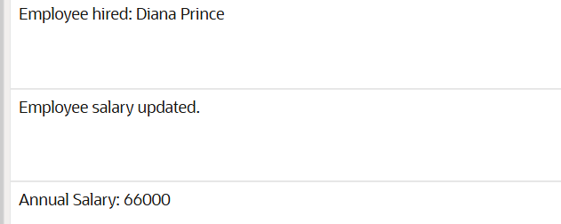

SCENARIO 3: Group all account-related operations into a package.

CREATE OR REPLACE PACKAGE AccountOperations AS

PROCEDURE OpenAccount(p_account_id NUMBER, p_cust_id NUMBER, p_type VARCHAR2, p_balance NUMBER);

PROCEDURE CloseAccount(p_account_id NUMBER);

FUNCTION GetTotalCustomerBalance(p_cust_id NUMBER) RETURN NUMBER;

END AccountOperations;

/

CREATE OR REPLACE PACKAGE BODY AccountOperations AS

PROCEDURE OpenAccount(p_account_id NUMBER, p_cust_id NUMBER, p_type VARCHAR2, p_balance NUMBER) IS

BEGIN

INSERT INTO Accounts (AccountID, CustomerID, AccountType, Balance, LastModified)

VALUES (p_account_id, p_cust_id, p_type, p_balance, SYSDATE);

DBMS_OUTPUT.PUT_LINE('Account opened: ' || p_account_id);

COMMIT;

EXCEPTION

WHEN DUP_VAL_ON_INDEX THEN

DBMS_OUTPUT.PUT_LINE('Error: Account ID already exists.');

ROLLBACK;

END;

PROCEDURE CloseAccount(p_account_id NUMBER) IS

BEGIN

DELETE FROM Accounts WHERE AccountID = p_account_id;

IF SQL%ROWCOUNT = 0 THEN

DBMS_OUTPUT.PUT_LINE('Account not found.');

ELSE

DBMS_OUTPUT.PUT_LINE('Account closed: ' || p_account_id);

END IF;

COMMIT;

END;

FUNCTION GetTotalCustomerBalance(p_cust_id NUMBER) RETURN NUMBER IS

v_total NUMBER;

BEGIN

SELECT NVL(SUM(Balance), 0) INTO v_total

FROM Accounts WHERE CustomerID = p_cust_id;

RETURN v_total;

END;

END AccountOperations;

/

BEGIN

AccountOperations.OpenAccount(10, 20, 'Savings', 800);

END;

/

DECLARE

v_total NUMBER;

BEGIN

v_total := AccountOperations.GetTotalCustomerBalance(20);

DBMS_OUTPUT.PUT_LINE('Total Balance: ' || v_total);

END;

/

BEGIN

AccountOperations.CloseAccount(10);

END;

/

**Output:**

